**Public Sentiments and Stock Market Reactions on Telehealth during COVID-19**

Digital Media Analysis

Professor Dr. Andy Ohemeng Asare

Group 5: Miguel Aguilar Garcia, Maryam Ahmed, Santiago Tellez Cordoba, Kate Armstrong, Dinika Rao, and Niloufar Seyedi Nezhad Someeh Saraei

George Brown College

December 7, 2021

Abstract

The COVID-19 pandemic has affected almost every industry in the world, but particularly the medical industry. The pandemic has forced medical professionals to change the way they see and treat patients, including a rapid expansion of telehealth. The purpose of this study is to examine public sentiments and the stock market reactions on the telehealth industry during the COVID-19 pandemic. Data was collected from Twitter API in two separate instances and resulted in 2,395 cleaned tweets that were analyzed using Tweepy Python Libraries.

Sentiment analysis revealed that 52.86% of tweets were positive, 36.62% were neutral, and 10.52% were negative. The primary topics discussed in tweets collected were Patient, Service, Future, Access, Preparation, Physician, Healthcare fields, and Pandemic. Sentiment analysis on the top eight topics is mostly positive, indicating that the public has a positive sentiment on the major topics of discussion in relation to telehealth.

A stock market analysis was performed on five companies in the telehealth industry from January 1, 2020, to October 22, 2021. COVID-19 had a clear positive correlation on stock prices of two companies in particular, UnitedHealth and Teladoc. There was much volatility during the 22-month period, but prices stabilized during the last three months for all five companies.

This study presents practical recommendations of reinvesting profits into telehealth services and infrastructure development, increased training for medical professionals, changing regulations around reimbursements, and targeting the needs of underserved populations.

**Keywords related to** **COVID-19 and Healthcare:** Primary Physician, Telehealth, Telemedicine, COVID-19, Stock Performance, Sentiment Analysis.

**NAICS Code:** 62111 - Offices of Physicians

Public Sentiments and Stock Market Reactions on Telehealth during COVID-19

Introduction

Telehealth is defined as “health care and information provided through electronic telecommunications, such as land based and wireless telephone, fax, email, and internet. It includes remote clinical care, public health, patient and professional education, and healthcare administration” (Alic & Splete, 2020). Telehealth is also known as telemedicine, digital health, e-medicine, e-health, and m-health.

The most important industry stakeholders are patients, physicians, healthcare providers and governments. These stakeholders will play a key role in the discussion and development of the report.

Importance of telehealth

The telehealth industry as a growing sub-sector within the primary and ambulatory care industry will have a far-reaching impact on not only how primary and ambulatory care is administered, but also in determining access to these services. The Commonwealth Fund conducted an analysis on findings from three early adopters of telehealth in the United States. Their findings revealed that “telemedicine and telemonitoring reduced hospitalizations, readmissions and healthcare costs while improving patient satisfaction and engaging patients in their own healthcare” (Curran, 2021).

The COVID-19 pandemic has had a huge impact on the telehealth medicine industry. A Statista report shows as of 2019, the telemedicine global market was valued at $50 billion USD and is projected to be valued at nearly $460 billion USD by 2030. The biggest driver of this growth is considered to be the COVID-19 pandemic (Statista, 2021).

Significance of Research

Determining how the public views telehealth, especially after the unprecedented demand for virtual care during the pandemic, is key in establishing what aspects of telehealth are beneficial. Public perceptions, coupled with growth forecasting, will allow us to evaluate the long-term acceptance and adoption of telehealth as a means of accessing primary and ambulatory care services. We may even go so far as to say that certain specialties which are historically associated with burnout in physicians, may be ripe for a move towards providing virtual care to its patients. A few of these specialties include psychiatry, urology, and dermatology (American Well, 2019).

If our findings determine a favorable outlook towards telehealth, and forecast an increase in favourability over time, then clinics and physician practices may find it useful to conduct many of their patient visits online.

In addition, virtual access to care providers based on restricted physician panels dictated by insurance plans will allow urban and rural customers to get appropriate care. If the public is more inclined to access primary healthcare virtually, this would also signal an increase in new entrants to the health insurance market, leading to a growth in competitive insurance plans and lower premium prices (Custer, 2020).

Research Objective

Even though digital technologies to provide healthcare have been present for many years; the recent pandemic and the subsequent rapid growth of business digitalization have increased the telehealth industry revenues. The objective of this paper is to examine public sentiments and stock market reactions on telehealth during COVID-19 pandemic. To fulfill this objective, the following areas of research were identified:

1. The keywords most frequently used by the public when discussing telehealth and COVID-19.
2. The public’s sentiment on telehealth during COVID-19.
3. The major topics of discussion during a discourse on telehealth and COVID-19.
4. The stock performance of telehealth and Health Information Services companies during COVID-19.

Literature Review

Industry Overview

The primary care industry in the US accounted for $254.5 billion in revenue in 2021 (Curran, 2021). Revenue in the global market for online doctor consultations has grown by 41.2% in 2020, with the United States seeing a 35% increase in revenue from online consultations alone (Statista, n.d.). It is interesting to note that the primary physician industry has not behaved the same as the telehealth subsector. According to IBISWorld, the American primary physician sector saw a decline of 7.75% in revenue in 2020, but a sharp increase of 8.29% by November 2021. This decline was mitigated by the implementation of telehealth services and changes to payment structures to allow physicians to charge for online consultations (Curran, 2021).

**Figure 1** Adoption rate of telemedicine among adults in the U.S. from 2010-2020, by channel

In sharp contrast is the primary physician sector in Canada, which was forecasted to grow by 2.6% between 2020-2025. The year 2020 alone saw an increase in revenue by 6.8% as the pandemic forced symptomatic patients to seek primary care doctors for medical assistance (Koronios, 2020).   
 The difference in market trends between the two is likely due to payment structures and Canada’s universal healthcare system. Despite telehealth making access easier, patients in the US were less likely to seek medical assistance even during a pandemic, due to unequal access to insurance and a lack of government funding available to primary care practitioners. Out of those that did seek virtual care, preference for video calls has grown over the past few years as evidenced in Figure 1 (Statista, 2021).

Impact of COVID-19 on telehealth

According to a survey done by Vivify Health in Texas; in the USA, after COVID-19 started, nearly eight out of ten people surveyed responded that they were very or somewhat interested in switching to a provider that allowed virtual visits. COVID-19 has made half of patients surveyed more eager to seek virtual treatment in the future. Virtual visits, according to the majority, can solve at least part of their medical issues. Only a tiny fraction of survey respondents stated their doctors have not ever offered telemedicine as a possibility (Vivify Health, 2020). Further, the findings of Vivify Health's annual virtual care survey confirmed the digital disruption and altering market and patient dynamics in the context of COVID-19.

Accelerated virtualization of primary care has occurred in correlation with the pandemic; however, not without challenges. Care providers have faced different challenges to provide remote services, including system implementation, cyber security, information privacy, and quality of care. As a result, caregivers are likely to invest more in IT infrastructure than training personnel in the use of that infrastructure (Mieles, 2021).

Beyond healthcare providers, governments have faced unexpected challenges in funding the rising demand for virtual care while having to cover additional expenses resulting from the pandemic induced economic downturn (Mieles, 2021). The United States waived regulations for Medicaid, Medicare, the Children’s Health Insurance Program (CHIP) and the Health Insurance Portability and Accountability Act (HIPAA) related to telehealth to ensure service and care was provided to those insured under Medicare, Medicaid, and CHIP. This change also reimbursed care providers for 80 additional services, delivered virtually, that had not been covered in the past (Faget, 2020).

The future of the telehealth industry post-COVID-19

The COVID-19 pandemic has stimulated business virtualization at an unprecedented rate. During the pandemic, many companies were forced to develop a technological infrastructure to survive and avoid bankruptcy. In the medical field, the rate of digitization can be inferred by the increase in funding for the digital health sector. According to StartUp Health’s research on funding in the digital health sector, the last decade shows an increasing investment trend starting from 1.1 billion USD in 2010 to 21.6 billion USD in 2020. It is interesting to note that 2020 is the period where the highest amount of funds was achieved; this single year represents a growth of 30% over the total decade (StartUp Health, 2021). When the specific segment of Telemedicine is analyzed, this field has received the highest amount of funding. According to Mercom Capital, this area earned 2.32 times more investment than the next highest category: Data Analytics (Mercom Capital, 2021).

Therefore, if the present rate of growth in investment funding continues, the predictions of another study may soon come to pass: “the market is expected to increase to over 500 billion U.S. dollars by 2025.” (Capgemini, 2018). This data allows us to perceive that the telemedicine segment will receive ample funding in the coming years and will grow exponentially over time.

Major topics of discussion in perception of telehealth

Taking into consideration what we discussed in this section, the most common topics of discussion are located between two of the major e-health participants, those who are providing care (physician/provider) and those receiving care (patient).

|  |  |
| --- | --- |
| **Patient** | **Physician/Provider** |
| Accessibility  Quality of care  Data privacy  Insurance  Services | Training  IT infrastructure  Best practices  Regulation  Cost  Investment |

Research Methodology

Overview of the Methodology

According to the objective of examining public sentiments and the stock market reactions of the telehealth industry during COVID-19, analysis was performed by executing a process that includes multiple stages: data collection, data cleaning and data storage. Firstly, Sentiment Analysis was conducted by extracting information from Twitter using JupyterNB and Python code. Secondly, information was extracted from Yahoo Finance with JupyterNB and Python. The data extracted was then cleaned and analysed using Python libraries.

Sentiment analysis methodology with Twitter

Data Collection.

Since the end of 2019, Twitter users have grown nearly 40% from 152 million users to 211 million users (Iqbal, 2021). This growth was due in large part to the ongoing COVID-19 pandemic and users wanting to stay connected to one-another in an ever-isolating world. This growth and the public sharing of information makes it an ideal social-media platform to collect public sentiment data (Bhatnagar & Choubey, 2021).

In order to analyse the public’s sentiment on telehealth during COVID-19, Twitter data was collected using Twitter API. The collected data was scraped, cleaned, and analysed using Python libraries and modules. Due to the limitation of Twitter API, the data was collected for two weeks in separate sessions and only one keyword applied. The collection began on November 20, 2021, and the data was scraped from Twitter from November 10, 2021, to November 19, 2021. Tweepy was used as the data scraping tool, using the keyword “telehealth”, which was identified from the literature review. Other filters that were applied were language and limit, as well as configuring Pandas which resulted in a total of 2,619 English tweets for further cleaning and analysis.

Data Cleaning Process.

From the unclean dataset, the data cleaning process included deduping, column elimination, tokenization, stop word removal, and removal of special symbols. Using drop_duplicates() and nunique() functions all duplicated tweets were eliminated. Out of 2,619 tweets, 2,395 were unique tweets and 224 were duplicated tweets.

There were 13 columns in total of which 10 irrelevant columns were dropped using df.drop() function. The columns that were dropped are: 'user_friends’, ‘user_name', 'user_description', 'user_followers', 'user_favourites', 'user_friends', 'hashtags', 'source', 'user_verified', 'user_created'.

The nltk.corpus python library was used to remove English stop words from the collected tweets. For example, words such as ‘i’, ‘me’, ‘my’, ‘myself’, ‘we’, ‘our’, ‘ours’, ‘ourselves’, ‘you’, and ‘you're’ were eliminated by loading the stopwords from NLTK library and using stopwords.words(“English”). The tweets were tokenized using the nltk.tokenize library in python. The regular expression function from textblob and emoji package was used to remove the special symbols like ‘#’, hyperlinks, mentions, and emojis.

Using the new dataframe ‘cleaned_texts’, analysis was conducted on tweets to generate a Wordcloud and sentiment analysis using Wordcloud and textblob libraries. A value between [-1, 1] was assigned to a tweet based on negative, neutral, or positive sentiment. The values generated were then converted to “negative”, “neutral” and “positive” labels. Subjectivity score was also assigned based on a range of [0,1] with scores closer to 1 labeled as “opinion” and those closer to 0 labeled as “fact”. The following libraries were used for topic modeling and identifying top keywords in each topic identified: pyLDAvis, CountVectorizer and LatentDirichletAllocation. Eight lists with keywords belonging to the same topics were generated and given appropriate labels. Using pyLDAvis and matplotlib, an Intertopic Distance Map was generated as well as a Topical Sentiment Analysis.

Stock market analysis methodology with Yahoo Finance

Data Collection.

Yahoo Finance is an open-source tool that provides a wide range of financial news. The main reason for choosing Yahoo Finance is the tool’s user-friendly interface with a wide range of functionality that facilitates the process of data collection and data storage. To analyse the stock market on telehealth during COVID-19, some Yahoo Finance APIs were selected, scraped, cleaned, and analysed using Python libraries, modules, and Excel. The data collection process began on October 22, 2021, and dates used for collection were from January 1, 2020, to October 22, 2021, to encompass the entire global pandemicto date (World Health Organization, 2021)**.** Using Python Jupyter notebook, data was scraped from Yahoo Finance and analysed using pandas, yfinance, plotly, cufflinks, plotly and matplotlib. The Pandas data reader allowed the mining of stock data using company codes for several days during the specified date range.

Company selection.

Using Yahoo Finance industry screener, companies that were classified as Healthcare: Health Information Services (HIS) were selected. A market capitalization filter was assigned to retain companies with a market cap of $2 billion or more. In addition, using secondary sources, top performing companies in the insurance and telehealth sectors were also identified, especially if those companies were providing telehealth services. In all instances, the companies had to be telehealth providers or involved in the process of providing telehealth.

The following companies were selected: UnitedHealth Group (UNH), Doximity (DOCS), Cerner (CERN), Teladoc (TDOC), and 1Life Healthcare (ONEM) (Yahoo Finance, 2021).

Data Cleaning Process.

From the unclean dataset exported from Python, based on Yahoo’s stock market information, the cleaning process was conducted using Excel. The data was filtered and cleaned manually. It was then organized and relabeled. All irrelevant columns were removed for easier analysis, leaving only the columns related to the date, price (adj close) and volume of market transactions.

Data Analysis.

Using word frequency, specific words were isolated to further analyse. These words were then used to inform sentiment analysis in order to understand how tweet data was clustered into specific topics of discussion. The keywords identified through word frequency were also used to conduct supervised topic modeling, by using the keywords as labels for topics.

Stock market data analysis used information provided by Yahoo Finance and the World Health Organization. Using COVID-19 data, specifically the number of cases reported by WHO and the spike in cases that are identified as 1st, 2nd, 3rd and 4th waves, a more nuanced analysis of stock market reactions was conducted to evaluate how telehealth companies performed during those specific timeframes.

Word Frequency

The first part of the analysis looks at the most popular tweets, which are grouped in a word cloud using the Python Wordcloud library. This was used to create a list of the most commonly used terms in the tweets. Furthermore, this method of analysis provides immediate insight or direct insights within a dataset. In most circumstances, word frequency can disclose what matters to the audience and leads to additional exploration.

Due to the limitations of Twitter API the data was collected in two separate instances. Figure 1 shows the word cloud for both instances of web scraping for the combined dates of November 10-19, 2021. Even though “telehealth” was the primary search keyword and the study focused on tweets that contained this keyword, it was observed that rural, access, patient, appointment, technology, and service were also tweeted together with the search keyword. These words had a high frequency of occurrence and were meaningful in answering our research question:

*Q1: The keywords most frequently used by the public when discussing telehealth and COVID-19.*

The words rural, patient and access provide some understanding of the public’s viewpoint about how patients in the rural areas are accessing telehealth services during COVID-19. Telehealth not only increases access to care in rural and underserved areas, but in urban and metropolitan areas as well. This increase and enhancement of access to care will lead to a lowering of healthcare insurance cost as more companies enter the growing market to bridge the gap in supply of telehealth services and insurance companies are forced to provide more competitive plans to a rising number of plan members (Custer, 2020).

Technology and health services play a major role in the telehealth industry, but COVID-19 has drastically impacted these two sectors (Renu, 2021). Not only have the number of telehealth companies grown during the pandemic, but the technology associated with telehealth has also revolutionised during a short period of time (Renu, 2021). From the use of AI to screen patients to the emergence of entire digital ecosystems that encompass health delivery, telehealth has seen a rise in technological advancements and the number of services that are now available to users, including, but not limited to, mental health therapy, wellness sessions, and diagnostic services (Business Wire, 2021). Moreover, technology allows COVID-19 positive and symptomatic patients a way to interact with their doctors via telehealth from the comfort of their homes (Renu, 2021). The word cloud in Figure 2 demonstrates how the words identified are some of the most frequently occurring keywords.

**Figure 2** *Wordcloud 10-19 November 2021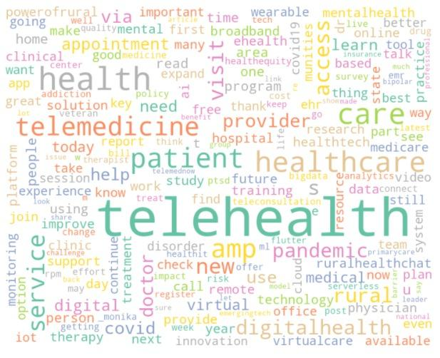*

Sentiment Analysis

Sentiment analysis studies people’s sentiments (attitudes, thoughts or judgements) towards certain entities or topics (Fang & Zhang, 2015). Following the word frequency analysis, a sentiment analysis was performed to identify the public's perceptions (positive and negative), and opinions regarding the identified keywords in order to address one of the objectives of this paper:

*Q2: The public’s sentiment on telehealth during COVID-19.*

The machine learning techniques in Python libraries that were used include textblob, seaborn, pandas, and matplotlib. These techniques were applied to identify the polarity of opinion of the scraped, cleaned, and combined tweets.

As illustrated in Figure 3, the polarity float is in the range of [-1, 1] with 1 indicating positivity and -1 indicating negativity. Most tweets are above 0.00, indicating a positive perception.

**Figure 3** *Polarity and Subjectivity Float*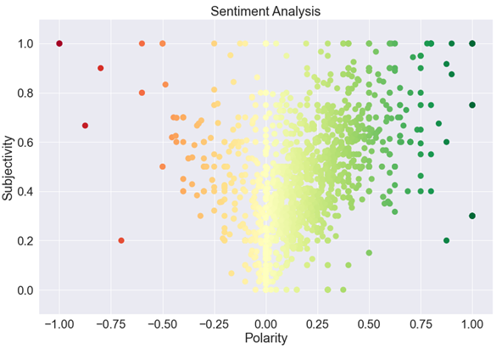

Further analysis on polarity sentiments (Figures 4 and 5) indicates that of the 2,395 cleaned tweets, 52.86% (1,266) were positive, 36.62% (877) were neutral, and 10.52% (252) were negative. Subjectivity sentiment indicated that 70.68% (1,693) tweets were opinions and 32.32% (702) were facts. This analysis has allowed insights into the polarity and subjectivity of public perception towards the identified keywords.

|  |  |
| --- | --- |
| **Figure 4** *Polarity Sentiment Analysis* | **Figure 5** *Subjectivity Sentiment Analysis* |
|  |  |

Topic Modeling and Sentiment Labeling

Topic Modeling can help find the most discussed relevant topics in tweets. LDA (Latent Dirichlet Allocation) and Python pyLDAvis packages were used to identify the primary topics and to provide an interactive visualization. Using the TF-IDF model in Natural Language Process, and by analysing the words used in tweets and their sentence structure, eight groups of topics were generated and each of the topic groups were given a specific weight based on how frequently they were used in tweets. As the term implies, TF-IDF calculates values for each word in a document through an inverse proportion of the frequency of the word in a particular document to the percentage of documents the word appears in. Words with high TF-IDF numbers imply a strong relationship with the document they appear in, suggesting that if that word were to appear in a query, the document could be of interest to the user (Ramos, 2003). Using topic modelling, the following research objective was fulfilled:

*Q3: The major topics of discussion during a discourse on telehealth and COVID-19.*

Table 1 (Appendix A) shows how each topic group was labeled under supervised machine learning technique to the most relevant topic. Topic 0 is more related to Patient, Topic 1 relates to Service, Topic 2 is related to Future and Topics 3, 4, 5, 6, and 7 are most related to Access, Preparation, Physician, Healthcare fields, and Pandemic, respectively. The mentioned topics are the top topics discussed in tweets related to telehealth. Figure 6 shows the 30 terms in Topic 0.

As shown in Figure 6, there is a relationship between the topics Patient, Service, Access, and Physician. Evidently, the recent pandemic has increased the utilization of telehealth due to social distancing and lockdown rules (Bruch, et al., 2021).

Therefore, there have been changes in the physician-patient relationship. There have also been amendments to the policies governing physicians when using telehealth; an increase in patient’s access to telehealth; and an increase in the different telehealth services provided such as mental health therapy, wellness sessions, and diagnostic services. Different studies have shown that mostly rural patients are very interested in using different telehealth services as they are more inclined and have less barriers to access their required medical assistance through telehealth (Weinzimmer, Dalstrom, Klein, Foulger, & de Ramierz, 2021).

There is also a connection between the topics Access and Service which also indicates the importance of patient’s access to telehealth and the services provided by it. Telehealth has lowered the geographical limitation of the physicians available for patients specially for rural patients. Patients can reach their medical assistance through different telehealth services. However, with COVID-19 becoming less of a concern over time, there are some new issues and concerns on patient’s access to telehealth services. As the pandemic slowly fades away from our lives, the policies that allow people to easily have access to physicians in different states through telehealth are retracted. This raises the demand to have broader regulations on telehealth for physicians who accept patients from other states and geographical localities post-pandemic (Shaw, 2021).

**Figure 6** *The top 30 most relevant terms for Topic 0* 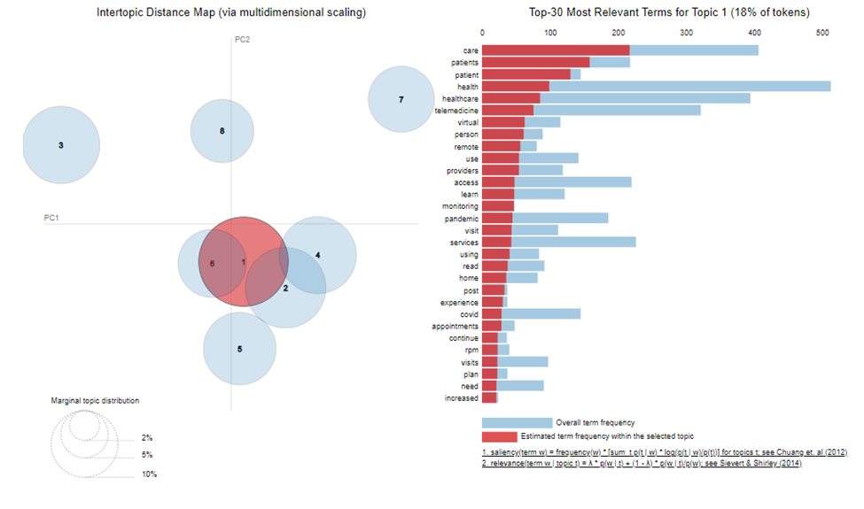

Sentiment analysis for each identified topic was also performed. Polarity percentage is provided in Table 2, and Figure 7 illustrates the polarity for each topic. As shown in Table 2, most of the topics have predominantly positive sentiments (50% or higher), with Preparation being the only one with more neutral than positive sentiments. This indicates that the public holds a largely positive outlook towards the topics discussed in relation to telehealth.

**Table 2** *Polarity analysis for each Topic*

|  |  |  |  |
| --- | --- | --- | --- |
| **Topic** | **Negative** | **Neutral** | **Positive** |
| **Patient** | 13% | 35% | 52% |
| **Service** | 9% | 36% | 55% |
| **Future** | 13% | 36% | 51% |
| **Access** | 8% | 32% | 60% |
| **Preparation** | 8% | 60% | 31% |
| **Physician** | 11% | 38% | 51% |
| **Healthcare fields** | 9% | 25% | 66% |
| **Pandemic** | 11% | 31% | 58% |

**Figure 7** *Sentiment analysis on each topic***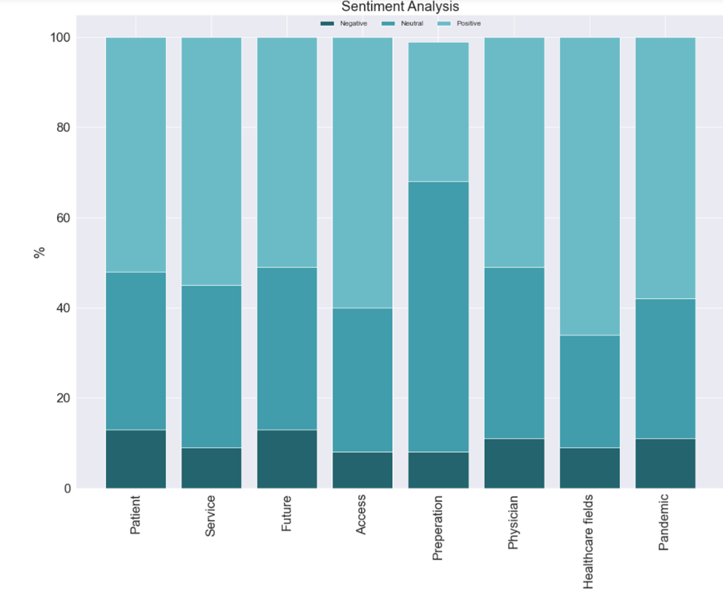**

Stock Market Trend Analysis

An analysis of telehealth and HIS companies was performed, comparing their stock prices and volume against the COVID-19 cases between January 2020 to October 2021. This analysis was used to answer the following objective:

*Q4: The stock performance of telehealth and Health Information Services companies during COVID-19.*

**Figure 8** *Trend showing Stock Prices and COVID-19 cases during four waves of the pandemic*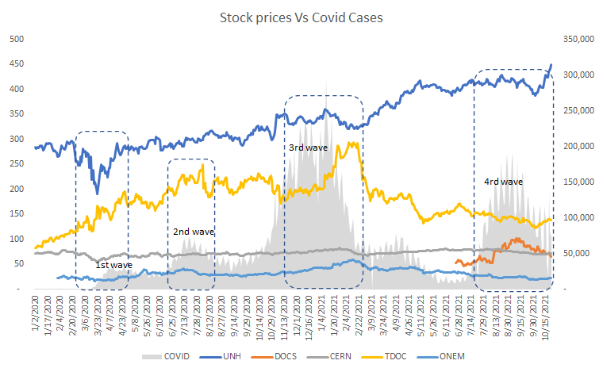

Doing a trend analysis between stock prices and COVID-19 cases during the time frame selected, it is quite evident that UnitedHealth (UNH) and Teladoc (TDOC) out-performed the other companies in terms of overall price increase during the pandemic. As can be seen in Figure 9, the first wave negatively impacted UNH while TDOC benefited from it. TDOC once again saw a spike in prices during the second and third waves, followed by a decline once the waves subsided. While the stock prices started to stabilize for most of the companies after the third wave, UNH has a clear uprising tendency because it is a diversified company in the healthcare industry with a robust finance structure, foreign investments, and software services (UnitedHealth Group Inc., 2021). Doximity (DOCS), which has recently started trading, has seen an increase in price over the last three months.

**Figure 9** *Stock prices and COVID-19 cases*

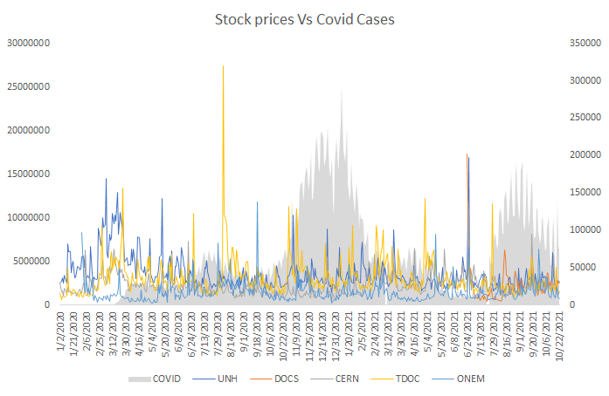

Other than the spike in volume in March 2020 following the lower stock prices, UNH has seen a steady trend in its stock volume. The stock volume has the normal behaviour of the market which usually are related to stock prices and the dynamics associated with the market itself. The spike in volume for TDOC’s share in the Q3 of 2020 is a direct consequence of the second COVID-19 wave and stock prices.

**Figure 10** *Boxplot analysis of stock prices*

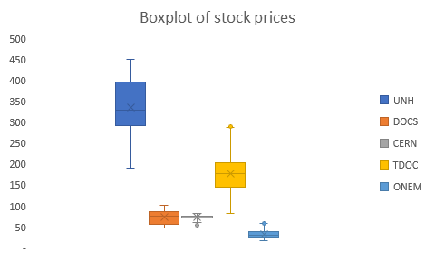

The boxplot price analysis in Figure 10confirms that UNH is the biggest company with an average stock price of approximately $330 USD, followed by TDOC. While these companies are the biggest, they are also the most volatile through the pandemic. TDOC’s stock price trend indicates that its stock performance is very sensitive to market changes, possibly due to its limited-service portfolio as a telehealth company.

Research Discussion

Based on the findings of Topic Modelling and Sentiment Analysis, the earlier findings of the report on the public’s willingness to adopt new technologies to improve access to health have been validated. Furthermore, the identification of specific topics of discussion allows the research study to triangulate areas where the telehealth industry should focus its efforts in order to maintain this level of positive sentiment. This includes increasing access to underserved populations like rural and low-income patients; changing regulatory frameworks to ensure insurance coverage for virtual care; providing adequate training to medical personnel; and increasing the number of health services available through telehealth.

The stock market analysis also identified how the pandemic affected telehealth and HIS companies. UNH and TDOC’s differing trends indicate how the pandemic has had a positive impact on telehealth companies.

Considering the findings of the research report, several practical and theoretical recommendations have been identified and outlined in the sections below.

Practical Recommendations

Given the rate of vaccination in the United States, it is conceivable that the initial positive outlook telehealth companies saw during the lockdowns will not continue at the same rate. This can already be seen in the price tapering off for Teladoc with a more traditional insurance provider like UnitedHealth making steady gains during the same period. For telehealth companies, this means that they will have to diversify their offerings to include other services as well. These might include offering cloud based EHR and EMR services like Cerner and Doxicity.

With physicians becoming increasingly familiar with digitized patient care and care coordination, it is probable a physician-centric service that aims to provide a host of services to the primary care providers will ensure telehealth and Health Information Systems companies continue to thrive. Another trend worth considering, is the digitizing of diagnostic-related services. With companies offering physical therapy diagnostic services online, it opens the arena for specialties that go beyond primary or urgent care.

Zigrang & Bailey-Wheaton (2021) identified regulatory challenges that telehealth providers may face in obtaining reimbursements for their services. The onus falls on governments to rework their insurance, coverage, and health information regulations to allow telehealth providers to continue providing virtual care beyond the pandemic. The US implemented the Social Security Act in response to the COVID-19 pandemic and to allow telehealth providers to be reimbursed for services (Faget, 2020). Learning from this example, all governments should waive similar restrictions and amend regulations in order to keep telehealth a mainstay in primary care provision.

In terms of adoption, telehealth has been welcomed with open arms across all populations and age groups. The sentiment analysis further validates this finding. However, one specific age group has been more reluctant to take to virtual care than others. Lam, Lu, & Shi (2020) conducted a survey of more than 4,500 adults aged 65 or older, of which over 70 percent showed signs of “unreadiness, including difficulty hearing or communicating or inexperience with the technology required” for virtual consultations. Strategies must be implemented by care providers and telehealth companies to mitigate the concerns of this age bracket, which accounts for 25% of all physician visits in the United States (Lam, Lu, & Shi, 2020) in order to continue the technology’s adoption rate. Some of the strategies might include providing consultations through a variety of channels that are more familiar, such as phone and video chat. Providing outreach support to nursing homes and retirement communities to on-board older patients to new platforms and apps will also ensure that their adoption rates go up.

An additional recommendation, based on the public sentiment analysis, is to train the healthcare service caregivers for better digital management skills. In the medical industry, and the telehealth sector specifically, caregivers are well educated, and therefore, likely quick learners of technological skills to improve their use of new infrastructure and technology. This practical recommendation will help improve the fact that patients do not feel comfortable doing consultations through a digital platform.

Kamimura et al., (2021) conducted a study on the experiences of uninsured patients of free clinics. Some of the factors associated with patient satisfaction of in-person versus telehealth visits during the pandemic in the US included ethnicity, language, and technical know-how. These findings indicate that patient satisfaction and their experiences are not the same. In telehealth, when there are no in-person face-to-face encounters, it is critical for clinicians to clearly explain things to patients. Prior to the pandemic, patients at free clinics had difficulty using technological communication devices. Providers must create strategies to effectively communicate medical information to patients who are unfamiliar with getting health information electronically via telehealth.

In addition to providing medical information, telehealth platforms must also find ways to include health education that focuses on lifestyle modifications, including food and physical exercise. This is significant because a large portion of the underserved and financially challenged population faces severe impacts in numerous parts of their lives as the pandemic quickly grows and alters daily living experiences. The consequences of a poor diet and lack of physical activity are particularly serious (Kamimura, Panahi, Meng, Sundrud, & Lucero, 2021). Access to free diet and nutrition resources, as well as including wellness training in health apps could ensure that telehealth addresses holistic health needs.

It is clear that telehealth is here to stay; but telehealth encompasses a wide range of platforms that can be utilised to provide care. Based on Statista’s *Digital Health* dossier, US adults surveyed between 2015 to 2020 showed a stark preference for adoption of Live Video as a method of delivery over all other channels i.e. live phone, text, email, picture or video, health app or website (Statista, 2021). Telehealth providers must offer live video to all care seekers in order to ensure their services are well-received.

Study Limitations and Recommendations for Future Research

The timeline of the data analysis for this research study was from January 2020 to November 2021. This period was chosen because it was the beginning of when COVID-19 was declared a global health emergency (World Health Organization, 2020) and the month that the analysis for this paper began. Unfortunately, the pandemic is currently ongoing and therefore no data or analysis has been conducted to measure further changes to public sentiment or stock market reactions. Therefore, the study is limited by the range of dates analysed and any future changes in factors that affect public sentiments or stock prices will not be covered under the conclusions reached by the researchers.

Through the stock market analysis, limitations of Yahoo Finance API were identified when using only publicly traded companies for analysis. Financial information is only available for companies that have gone public (IPO). This limitation prevents a deeper analysis for the whole sector as telehealth is a growing industry and access to financial information from smaller companies that have not gone public is not the scope of Yahoo Finance.

Secondary sources were used to allow for the identification of the investment growth in the entire industry. However, it is impossible to infer the specific areas where the money was invested, and which companies actually did invest. Therefore, for future research it would be important to focus only on the performance of two companies and try to analyze their economic results, service performance and re-investment policies.

The use of Twitter API for the collection of tweet data used in Word Frequency, Sentiment and Polarity Analysis, and Topic Modeling is an inherently flawed technique. With Twitter’s changing guidelines and restrictions for developers, data collected through Tweepy is restricted to a period of 7 days. This forces researchers to continuously collect and collate data to perform comprehensive analysis over a period of time. In addition to this, the keyword restrictions in Tweepy do not allow the use of multiple keywords in order to fine tune the selection of tweets more relevant to the research objective.

In order to conduct more rigorous research on this topic in the future, continuous collection of data over a period of months is recommended, unless Twitter significantly changes how it allows developers to scrape data. The scope of this study simply could not encompass such a large date range, but future studies can use this paper as a benchmark when conducting similar analysis.

Conclusion

This study was aimed at analyzing public sentiments and stock market reactions of the telehealth industry during the COVID-19 pandemic. Research revealed that the pandemic had a positive economic impact on the telehealth industry and growth expectations are very interesting for the next decade. It is recommended that profits obtained should be reinvested in services, in order to cover expected growth and to be able to provide customers better virtual services. Companies like UnitedHealth and Teladoc were able to leverage the pandemic to improve their financial outcome. However, this industry is still developing, and there is a need to change regulations, consolidate systems, and overcome resistance to change by caregivers and customers.

The public’s sentiment towards telehealth during COVID-19 has been primarily positive, with areas such as accessibility, services and technology, and physicians being the major topics of discussion. Using these areas of discussion, the study has recommended that governments amend their healthcare and coverage regulations to favor telehealth provision; telehealth companies should diversify their portfolios to continue growing; and services in telehealth should encompass a wide range of users, including underserved populations and the elderly.

References

Alic, M., & Splete, H. (2020). *The Gale Encyclopedia of Public Health* (2 ed., Vol. 2). (B. Narins, Ed.) GALE CENGAGE REFERENCE. Retrieved from https://go.gale.com/ps/i.do?p=HWRC&u=toro15002&id=GALE|CX7947900273&v=2.1&it=r&sid=bookmark-HWRC&asid=ca1c2352

Alpert, G. (2020, March 24). *Top 5 Telemedicine Companies for 2021.* Retrieved from Investopedia: https://www.investopedia.com/articles/insights/120316/top-5-companies-telemedicine.asp

American Well. (2019). *Telehealth Index: 2019 Physician Survey.* Retrieved from Telehealth Index: 2019 Physician Survey: https://static.americanwell.com/app/uploads/2019/04/American-Well-Telehealth-Index-2019-Physician-Survey.pdf

Becker, K. (2021, May 7). *Best Telemedicine Services of 2021.* Retrieved from Insider: https://www.insider.com/best-telemedicine-services

Bestsennyy, O., Gilbert, G., Harris, A., & Rost, J. (2021, July 9). Telehealth: A post-COVID-19 reality? *McKinsey*. Retrieved from https://www.mckinsey.com/industries/healthcare-systems-and-services/our-insights/telehealth-a-quarter-trillion-dollar-post-covid-19-reality

Bhatnagar, S., & Choubey, N. (2021, May 3). Making sense of tweets using sentiment analysis on closely related topics. *Soc. Netw. Anal. Min., 11*(44). Retrieved from https://rdcu.be/cCyPD

Bruch, D., Muehlensiepen, F., Alexandrov, A., Konstantinova, Y., Voß, K., Ronckers, C., . . . May, S. (2021, November). The impact of the COVID-19 pandemic on professional practice and patient volume in medical practices: A survey among German physicians and psychotherapists. *Zeitschrift für Evidenz, Fortbildung und Qualität im Gesundheitswesen, 166*, 27-35. doi:https://doi-org.gbcprx01.georgebrown.ca/10.1016/j.zefq.2021.08.001

Business Wire. (2021, October 14). *Amwell's Converge Virtual Care Platform Hailed as Best New Application in Telehealth*. Retrieved from Business Wire: https://www.businesswire.com/news/home/20211014005310/en/

Capgemini. (2018). *Digital Health - Transforming Healthcare.* Retrieved from Capgemini: https://www.capgemini.com/be-en/wp-content/uploads/sites/17/2018/10/Digital-health-final-paper-22.10.pdf

Curran, J. (2021, November). *Primary Care Doctors in the US - Operating Conditions.* Retrieved from IBISWorld: https://my-ibisworld-com.gbcprx01.georgebrown.ca/us/en/industry/62111a/operating-conditions

Custer, W. S. (2020, September). Telehealth. *Journal of Financial Service Professionals, 74*(5), 34-36. Retrieved from https://web-p-ebscohost-com.gbcprx01.georgebrown.ca/bsi/detail/detail?vid=0&sid=9dcefbdf-ba7b-4a3e-9b6a-78275fdd473c%40redis&bdata=JnNpdGU9YnNpLWxpdmUmc2NvcGU9c2l0ZQ%3d%3d#AN=145310262&db=bth

Faget, K. Y. (2020, June). Telehealth in the Wake of COVID-19. *Journal of Health Care Compliance, 22*(3), 5-66. Retrieved from https://login.gbcprx01.georgebrown.ca/login?url=https://search.ebscohost.com/login.aspx?direct=true&db=bth&AN=143187767&site=bsi-live&scope=site

Fang, Z., & Zhang, J. (2015, June 16). Sentiment analysis using product review data. *Journal of Big Data, 2*(5). Retrieved from https://journalofbigdata.springeropen.com/articles/10.1186/s40537-015-0015-2

Gibbons, S. (2021, April 22). *6 Companies That Are Taking Telemedicine By Storm.* Retrieved from Forbes: https://www.forbes.com/sites/serenitygibbons/2021/04/22/6-companies-that-are-taking-telemedicine-by-storm/?sh=7a4f34366217

Iqbal, M. (2021, November 12). *Twitter Revenue and Usage Statistics (2021).* Retrieved from Business of Apps: https://www.businessofapps.com/data/twitter-statistics/

Kamimura, A., Panahi, S., Meng, H.-W., Sundrud, J., & Lucero, M. (2021, July 26). Patient Satisfaction With Telehealth and Experiences During the COVID-19 Pandemic Among Uninsured Free Clinic Patients. *Journal of Patient Experience, 8*. Retrieved from https://journals.sagepub.com/doi/10.1177/23743735211033107

Kolakowski, M. (2020, July 30). *10 Biggest Healthcare Companies.* Retrieved from Investopedia: https://www.investopedia.com/articles/markets/030916/worlds-top-10-health-care-companies-unh-mdt.asp

Koronios, E. (2020, June). *Primary Care Doctors in Canada - Operating Conditions.* Retrieved from IBISWorld: https://my-ibisworld-com.gbcprx01.georgebrown.ca/ca/en/industry/62111aca/operating-conditions

Lam, K., Lu, A. D., & Shi, Y. (2020, August 3). Assessing Telemedicine Unreadiness Among Older Adults in the United States During the COVID-19 Pandemic. *JAMA Network*. Retrieved from https://jamanetwork.com/journals/jamainternalmedicine/fullarticle/2768772

Mercom Capital. (2021, May 21). *Top funded digital health categories worldwide in 2020 [Infographic].* Retrieved from Statista: https://www-statista-com.gbcprx01.georgebrown.ca/statistics/736163/top-funded-health-it-technologies-worldwide/

Mieles, C. (2021, April). *Hospitals in Canada - Industry Jargon.* Retrieved from IBISWorld: https://my-ibisworld-com.gbcprx01.georgebrown.ca/ca/en/industry/62211ca/about#industry-jargon

Ramos, J. (2003, January). Using TF-IDF to determine word relevance in document queries. Retrieved from https://citeseerx.ist.psu.edu/viewdoc/download?doi=10.1.1.121.1424&rep=rep1&type=pdf#:~:text=Essentially%2C%20TF%2DIDF%20works%20by,is%20in%20a%20particular%20document.

Renu, N. (2021, January 1). Technological advancement in the era of COVID-19. *SAGE Open Medicine, 9*. Retrieved from https://journals.sagepub.com/doi/10.1177/20503121211000912

Shaw, G. (2021, November 4). The Challenges of Maintaining Telehealth Access in a Post-Pandemic World. *Neurology Today, 21*(21), 19-21.

StartUp Health. (2021, January 15). *StartUp Health Insights 2020 Year-End Report.* Retrieved from Statista: https://www-statista-com.gbcprx01.georgebrown.ca/statistics/388858/investor-funding-in-digital-health-industry/

Statista. (2021). *Digital Health Dossier.* Retrieved from Statista: https://www-statista-com.gbcprx01.georgebrown.ca/study/27232/digital-health-statista-dossier/

Statista. (n.d.). *Online Doctor Consultations - Worldwide.* Retrieved September 2021, from Statista: https://www-statista-com.gbcprx01.georgebrown.ca/ outlook/dmo/digital-health/ehealth/online-doctor-consultations-/worldwide

Stewart, C. (2021, June 4). *Telemedicine use in the US 2015-2020, by channel [Infographic].* Retrieved from Statista: https://www.statista.com/statistics/1219721/telemedicine-use-in-the-us-by-channel/

UnitedHealth Group Inc. (2021, November 8). UnitedHealth Group Incorporated SWOT Analysis. 1-7.

Vivify Health. (2020, July 9). *New Survey: COVID-19 Has Made Patients Warm Up to Telehealth, Report Positive Experience.* Retrieved from PR Newswire: https://www.prnewswire.com/news-releases/new-survey-covid-19-has-made-patients-warm-up-to-telehealth-report-positive-experience-301090490.html

Weinzimmer, L. G., Dalstrom, M. D., Klein, C. J., Foulger, R., & de Ramierz, S. S. (2021, July). The relationship between access to mental health counseling and interest in rural telehealth. *Journal of Rural Mental Health, 45*(3), 219-228. Retrieved from https://doi-org.gbcprx01.georgebrown.ca/10.1037/rmh0000179

World Health Organization. (2020, January 30). Statement on the second meeting of the International Health Regulations (2005) Emergency Committee regarding the outbreak of novel coronavirus (2019-nCoV). *WHO | World Health Organization*. Retrieved from https://www.who.int/news/item/30-01-2020-statement-on-the-second-meeting-of-the-international-health-regulations-(2005)-emergency-committee-regarding-the-outbreak-of-novel-coronavirus-(2019-ncov)

World Health Organization. (2021, December 3). *Number of new cases of coronavirus (COVID-19) in the United States from January 20, 2020 to December 2, 2021, by day.* Retrieved from Statista: https://www-statista-com.gbcprx01.georgebrown.ca/statistics/1102816/coronavirus-covid19-cases-number-us-americans-by-day/

World Health Organization. (2021, January 25). *Timeline: WHO's COVID-19 response.* Retrieved from World Health Organization: https://www.who.int/emergencies/diseases/novel-coronavirus-2019/interactive-timeline?gclid=CjwKCAjwwsmLBhACEiwANq-tXDE2HFKwEhX3vP_YP79iewG7bp45lFnGFfp-qORKDAkWCx2_4tLO5xoC9TQQAvD_BwE#event-1

Yahoo Finance. (2021). *Yahoo Finance Screener.* Retrieved October 2021, from Yahoo Finance: https://finance.yahoo.com/screener

Zigrang, T., & Bailey-Wheaton, J. (2021, July/August). Valuation of Telemedicine: Introduction (Part I of V). *Value Examiner*, 35-39. Retrieved from https://login.gbcprx01.georgebrown.ca/login?url=https://search.ebscohost.com/login.aspx?direct=true&db=bth&AN=152117474&site=bsi-live&scope=site

Appendix A

Table 1: Eight topics and their relevant word groups using LDA topic model

|  |  |
| --- | --- |
| Possible Topic Label | Top 10 words for topic #0 |
| Patient | ['increased', 'need', 'plan', 'visits', 'rpm', 'continue', 'appointments', 'covid', 'experience', 'post', 'home', 'read', 'using', 'services', 'visit', 'pandemic', 'monitoring', 'learn', 'access', 'providers', 'use', 'remote', 'person', 'virtual', 'telemedicine', 'healthcare', 'health', 'patient', 'patients', 'care'] |
|  | Top 10 words for topic #1 |
| Service | ['growth', 'weekly', 'insurance', 'access', 'cms', 'twitter', 'fee', 'expanded', 'cures', 'digitalhealth', 'state', 'federal', 'shared', 'free', 'reports', 'medtwitter', 'read', 'services', 'medicaid', 'key', 'covid', 'market', 'physician', 'medtech', 'link', 'policy', 'new', 'pandemic', 'medicare', 'health'] |
|  | Top 10 words for topic #2 |
| Future | ['doctor', 'safe', 'solutions', 'primary', 'list', 'patients', 'new', 'use', 'treatment', 'providers', 'need', 'covid', 'time', 'innovation', 'mentalhealth', 'people', 'pandemic', 'improve', 'hospital', 'doctors', 'survey', 'help', 'mental', 'medical', 'therapy', 'access', 'services', 'care', 'health', 'amp'] |
|  | Top 10 words for topic #3 |
| Access | ['want', 'internet', 'tool', 'job', 'providers', 'time', 'work', 'learn', 'know', 'today', 'register', 'virtual', 'technology', 'new', 'health', 'need', 'check', 'services', 'munities', 'healthcare', 'join', 'day', 'like', 'ruralhealthchat', 'amp', 'powerofrural', 'broadband', 'rural', 'access', 'appointment'] |
|  | Top 10 words for topic #4 |
| Preparation | ['pandemic', 'covid', 'mhealth', 'healthcareit', 'teleconsultation', 'primarycare', 'new', 'flutter', 'emergingtech', 'serverless', 'healthit', 'emr', 'analytics', 'technology', 'bigdata', 'healthequity', 'cloud', 'future', 'amp', 'iot', 'wearables', 'ehr', 'digital', 'ehealth', 'healthtech', 'data', 'health', 'telemedicine', 'digitalhealth', 'healthcare'] |
|  | Top 10 words for topic #5 |
| Physician | ['amp', 'use', 'start', 'states', 'virtual', 'program', 'solution', 'love', 'platform', 'news', 'forward', 'office', 'provider', 'mental', 'good', 'training', 'talk', 'services', 'easy', 'tbhi', 'healthcare', 'digital', 'online', 'state', 'medical', 'today', 'practice', 'health', 'doctor', 'telemedicine'] |
|  | Top 10 words for topic #6 |
| Healthcare fields | ['study', 'group', 'support', 'health', 'chapel', 'trinity', 'wesley', 'industry', 'visits', 'working', 'program', 'digital', 'leaders', 'work', 'research', 'based', 'online', 'evidence', 'patients', 'covid', 'best', 'training', 'make', 'visit', 'new', 'clinical', 'pandemic', 'learn', 'amp', 'help'] |
|  | Top 10 words for topic #7 |
| Pandemic | ['treating', 'big', 'video', 'year', 'mentalhealth', 'gains', 'like', 'providers', 'study', 'opioid', 'showed', 'lot', 'great', 'look', 'effort', 'think', 'huge', 'access', 'ruralhealth', 'addiction', 'treatment', 'bipolar', 'visits', 'service', 'treat', 'veterans', 'ptsd', 'disorder', 'areas', 'rural'] |